Muhammad Anas 25k-0899
Task 1:
TT:
A1​ | A0​ | B1​ | B0​ | L (A<B) | E (A=B) | G (A>B)
0 | 0 | 0 | 0 | 0 | 1 | 0
0 | 0 | 0 | 1 | 1 | 0 | 0
0 | 0 | 1 | 0 | 1 | 0 | 0
0 | 0 | 1 | 1 | 1 | 0 | 0
0 | 1 | 0 | 0 | 0 | 0 | 1
0 | 1 | 0 | 1 | 0 | 1 | 0
0 | 1 | 1 | 0 | 1 | 0 | 0
0 | 1 | 1 | 1 | 1 | 0 | 0
1 | 0 | 0 | 0 | 0 | 0 | 1
1 | 0 | 0 | 1 | 0 | 0 | 1
1 | 0 | 1 | 0 | 0 | 1 | 0
1 | 0 | 1 | 1 | 1 | 0 | 0
1 | 1 | 0 | 0 | 0 | 0 | 1
1 | 1 | 0 | 1 | 0 | 0 | 1
1 | 1 | 1 | 0 | 0 | 0 | 1
1 | 1 | 1 | 1 | 0 | 1 | 0
Expression:
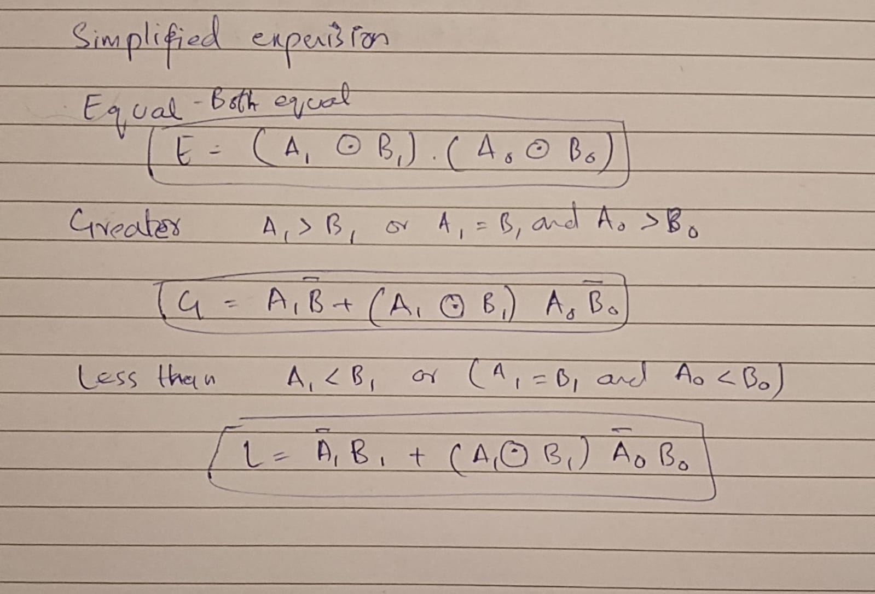

Circuit Diagram:
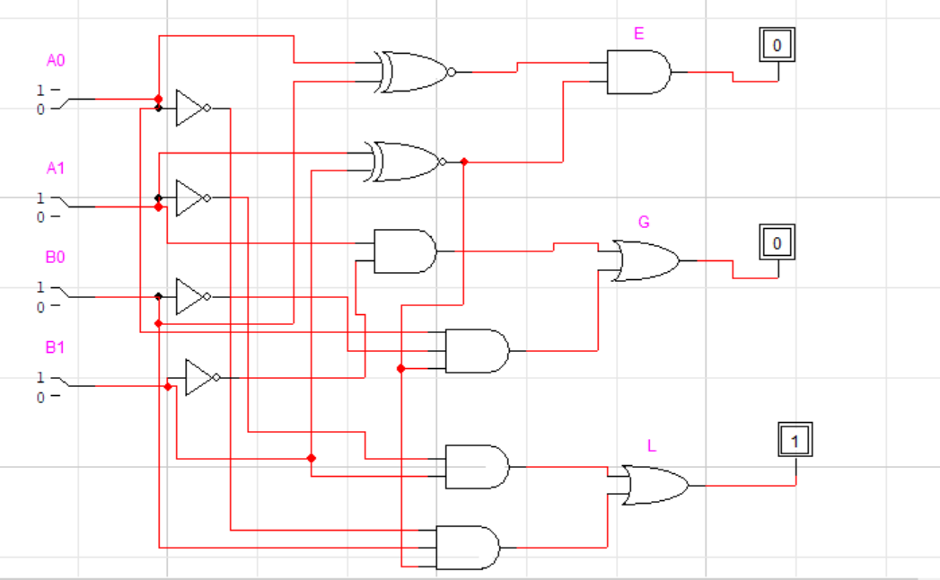

1-bit comparator:
Circuit implementation
